**MRI instrumentation**

**Diffusion MRI**

**diffusion-weighted imaging (DWI) technology:**

The water diffusion can be detected or measured using the diffusion-weighted imaging (DWI) technology. DWI is sensitized to the random molecular motion of water in tissue by applying magnetic field gradients (diffusion gradients) in the RF pulse sequence. In a DWI sequence, the diffusion weighting is determined by a parameter called “b-value,” which is in the unit of second per square millimeter (s/mm2). High “b-value” generates high diffusion weighting, and no diffusion weighting is generated when b = 0. On a diffusion-weighted image, the tissue that contains high diffusing water generates hypointense signal. A map of apparent diffusion coefficient (ADC) of water molecules can be calculated from the diffusion-weighted image.

**DWI application:**

The use of DWI on neurological studies has been shown that a wide range of neuropathology causes DWI signal changes. One of the most successful applications is in the stroke study. T1- and T2-wt MRI failed to detect the ischemic lesion in acute stroke. On the other hand, the lesion can be detected using DWI. Studies have shown that DWI can reveal the immediate temporal changes in ADC that occur upon induction of ischemia. The figure shows the DWI and the ADC map of a stroke model using rats. The ischemic region has elevated DWI signal intensity indicating decreased water diffusion in this region. ADC map calculated from the DWI shows decreased ADC in the same region.

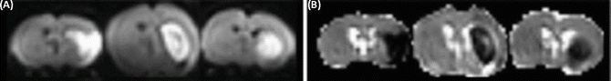

The underlying pathology of the ADC change during ischemia remains unclear. Several theories exist that try to explain the observation. One of them is the cell swelling theory. This theory assumes that water diffusion is slower inside cells than in the extracellular space. The disruption of blood supply in stroke induces cell swelling (cellular edema). Water molecules then spend more time diffusing in swollen cells, and thus decreasing ADC. Another theory assumes that the changes in cell membrane permeability may contribute to the ADC reduction. A loss of active intracellular water transport with energy failure may be another cause of the decreased water diffusion..

**Diffusion Tensor Imaging (DTI):**

DTI is an extension of DWI. Diffusion is a three-dimensional process. In a uniform environment, it is isotropic in all directions and can be represented by a sphere. If water molecule movement is restricted in certain directions, the diffusion becomes anisotropic, represented by an ellipsoid. For example, in fiber-like cell structures, such as white matter tracts, the diffusion is relatively free along the long axis of the fiber tract, but restricted in the other two dimensions. The diffusion in cellular structures is described mathematically by a tensor. A tensor is a 3 × 3 matrix. The diffusion tensor can be measured using DTI with diffusion gradients in appropriate strength. After a series of mathematical manipulations, the axes of the diffusion ellipsoid and the diffusion magnitudes along the axes can be calculated.

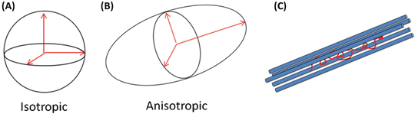

**Applications:**

Apparently the principal axis (the axis with the maximum diffusion magnitude) of the diffusion ellipsoid points to the preferred diffusion direction. It is reasonable to think that for WM, the favorite diffusion direction is along the WM tracts, and thus the principal axis is parallel to fiber tract orientation. Several methods have been proposed to display the principal axis, one of which is the so-called color-encoding technique. In the color-encoding technique, the three components along x, y, and z directions of the principal axis are encoded with the primary colors (red, x component; green, y component; and blue, z component) and the brightness is scaled by an anisotropy index such as FA. The figure shows an example of this method on multiple image slices of a mouse brain where the brightness was scaled by the FA value.

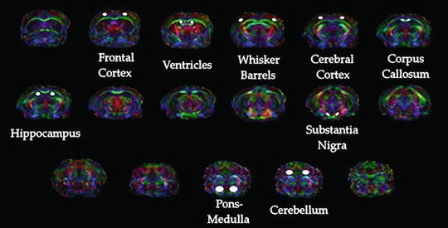

**MRI contrast and DWI:**

Since its inception in 1985, diffusion weighted magnetic resonance imaging has been evolving and is becoming instrumental in diagnosis and investigation of tissue functions in various organs including brain, cartilage, and liver. Even though brain related pathology and/or investigation remains as the main application, diffusion weighted magnetic resonance imaging (DWI) is becoming a standard in oncology and in several other applications.

**Advantages of adding DWI to conventional MRI sequences:**

DWI is particularly useful in several cases, where conventional MR sequences like T2 weighted imaging (T2WI) do not show significant changes in the images. For instance, in pathological conditions like stroke arising from ischemia, signal intensity on T2WI does not change until at least 8 h after the onset of stroke and then appears hyper-intense in the stroke region. However, DWI and ADC maps can show the changes in brain as early as 30 min or even earlier, after the onset of stroke. The signal intensity changes over time in DWI and ADC maps, changing from hyper-intense signal to hypo-intense signal on DW images and from hypo-intense to hyper-intense signal on ADC maps, from acute to chronic stage. Pathological changes like these can be detected in its early stages using diffusion images of DWI, even when other modes of imaging might not show significant changes in tissue.

Typically, diffusion is restricted in solid tumors. While conventional MR sequences like T2WI can detect most of the tumors, employing only these conventional sequences would limit the diagnosis due to false positive findings that are commonly present, such as benign prostatic hyperplasia, hemorrhage, hormonal therapy and concomitant prostatitis. Employing DW images and ADC maps, which show hyper-intense signal and hypo-intense signal in tumor regions respectively, would limit false positive diagnosis. However, the conventional MR sequences cannot be completely replaced by DWI alone because of the lower image quality (resolution, noise, blur, etc.) and artifacts present in the DW images. In addition, sequences like T2WI provide anatomical information, which DW imaging cannot provide since it concerns more with diffusion related changes in the tissue. Hence, DWI is suitable to complement the conventional MR sequences by providing diffusional information, to increase the clinical confidence and reduce false positives arising from using only one imaging technique.

In ischemia, DW images clearly show superiority in identifying stroke onset area, even when conventional MR sequences couldn’t show any significant changes. According to a study about this topic by Lansberg MG and Norbash AM , the addition of DWI improves the accuracy of stroke region identification in the first 48 h after onset of stroke.

Another study by Kinner et al shows that a 10% improvement in diagnostic confidence by the addition of DW images to T2 weighted and contrast enhanced T1 weighted images for the detection of lesions in bowel MRI. The value addition of DWI for discriminating malignant and benign focal liver lesions and concluded that the combination of T2 weighted and DWI improves diagnostic confidence. Similar conclusion was drawn by Le Moigne et al. For characterizing small hepatocellular carcinoma in case of cirrhotic liver, in identifying false positive lesions in liver. the combination of super-paramagnetic iron oxide (SPIO)-enhanced MRI and DWI improved the detection of hepatocellular carcinoma in comparison to SPIO alone. Finally, A study by Haider et al ,concluded that combination of T2 and DW MRI is better in detection and localization of prostate cancer than using T2 MRI alone. Therefore, employing DWI with conventional MR imaging improves diagnostic confidence. Since DWI has the advantage of being acquired very rapidly without specialized hardware, it can be performed in the same sitting along with conventional MR sequences. A basic sequence can be completed in 1.5 to 3 min and may be interpreted either visually (as greyscale imaging) or quantitatively (as a function of diffusivity, i.e., ADC). The A figure shows T2WI and DWI scan images of a prostate cancer patient. B figure is diffusion weighted image and C,D figures are corresponding ADC maps shown in greyscale and in color map.

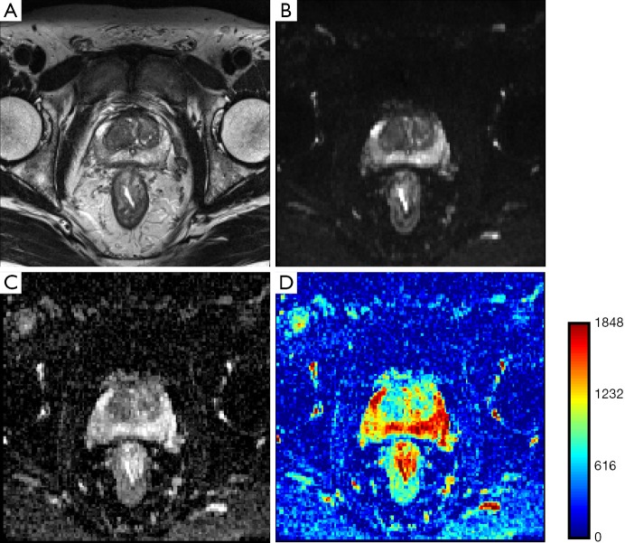

**DWI for brain imaging:**

DWI is currently a standard in diagnosis of ischemic stroke since diffusion changes can be seen early in DW images and ADC maps . In addition to stroke, DWI is also used in diagnosis of epilepsy and neurotoxicity. Fiber tracking or tractography was achieved through Diffusion Tensor Imaging (DTI), which branched off from DWI. DTI relies on estimating diffusion tensors, which can be obtained through taking DW images in multiple directions. In white matter of brain, diffusion is assumed to be highest, parallel to the tract and studying this anisotropic diffusion would enable us in mapping white matter pathways (white matter tractography). Through DTI of gray matter, connectivity in brain could be understood better. Studying white matter and gray matter in brain, not only helps advance our knowledge on anatomy of brain , but also allows the diagnosis of white matter and gray matter related pathologies like lesions, axonal injuries, demyelination, multiple sclerosis ,psychiatric disorders like Schizophrenia, ADHD and neurological and neuro-degenerative disorders like cognitive impairment, Alzheimers’ disease etc, Currently, tractography is also used in parcellation and connectivity mapping in brain, in the Human Connectome Project, which aims at mapping the brain at regional level

**Challenges with DWI:**

In current clinical settings, most of the MR scanners operate at 1.5T or 3T. The gradient coils can generate gradient magnitudes around 40 mTm−1 and can switch up to a rate of 200 Tm−1·s−1 ,and would enable DW measurements up to b-values, approximately of order 1,000 ,So far, Echo Planar Imaging (EPI) sequences like Single-Shot EPI (SS-EPI) that enable faster image acquisition in short time, typically 20-100 ms are being used clinically. On a 3T scanner, SS-EPI can achieve a DW image with acquisition matrix of 128 × 128 and an isotropic resolution limited to 2 mm. In anisotropic scans, in-plane resolution can be improved to 1 mm, but at a lower Signal-to-Noise Ratio (SNR) .

The physics behind diffusion image acquisition assumes perfect field homogeneity, infinitely fast gradient changes, perfectly shaped RF pulses, etc. However, in reality, this is impossible because of power requirements, hardware limitations and other external factors, which limit DWI accuracy and result in lower image quality and other artifacts in the image. Due to its requirements like the need for faster acquisition, very strong gradients, perfect field homogeneity etc., which are not feasible with the existing hardware, the images acquired from DWI fall short of other MR images like T2WI in terms of image quality, like distortion, noise, low resolution, and limited morphological interpretability.